Cmd k to delete tag

Extesions

**Live Server Preview by negokaz**

**Liver server by ritwik dey**

Ctrl Shift p

Each and every tag has their importance

Structutre of HTML

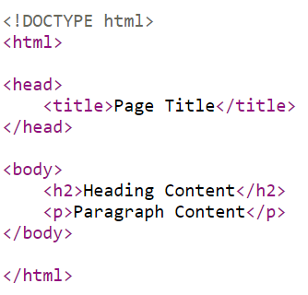

<!DOCTYPE html> tells brow that doc type is HTML

Meta tages are info about about doc that you want to write used for bot

<meta charset="UTF-8"> character set (16 for emoji)

<meta name="viewport" content="width=device-width, initial-scale=1.0"> jewha render honar te tyach kay zoom level rahnar, tab vr ks disel web iste vr ks disel

Google che matags chnagle ahet karn google vrch site list kraychi ahe aplyala

<https://developers.google.com/search/docs/crawling-indexing/special-tags>

meta: nntr stv type meta tag show hona

jr tag open kel tr close kra

kahi tag close nhihot tr te self close kra ex. <br/>

**Heading, paragraph and reading docs**

Tags mdhe nesting kru shkto body mdhe h1 is example

<h1 title="heading one and I am property while h1 is tag">HEadigng</h1>

    <h2>HEading  <span>two</span></h2>

H1 he tag ahe title he property ahe (title mhnje hover kelyavr tyatl text shownhot )

Attributes :- person is tall, tall is attribute

Anchor tag used to open link

Href hypertext reference

A: select blank

<a href="http://" target="_blank" rel="noopener noreferrer"></a>

3

Target mdhe ctrl space > option 4 show honar

A tag mdn vr info milu shkte

Pratyek tag mdge comp ani optional attr astat

A tag chta working sathi a tag lagnar

p>lorem50

muliple jage vr same chnages krayche asel tr alt click kra

alt z ne wrap hot

br for new line , break line used for poem and code

or use pre tag

hr horiz line

# Formatting style and Global attributes

Ctrl / for commenting

Comment mdhl vie page source mdheb diste , information leak

B and strong for bold, diff is strong new age mdhe use hoto for emphasis but bold fkr bold krayla

I for italicize

Em emphasis

Ul>li*4

Homewrok

B, strong , I, em , small, sup, sub, del, mark

Ek page vr ekch h1 headin ghwi

Readability is the top most priority

Style tag HTML mdn

Global atttrbute available everywhere

<https://developer.mozilla.org/en-US/docs/Web/HTML/Global_attributes>

<body style="background-color: black; color: white;">

<p style="background-color: red;">

Ny this way we can apply style to HTML doc

# Value of colors and CSS format

Hex values is used in companies , becaure normal naming colour renders(interprets) differrently in diff browser

Hex – rgb used mostly

Hsl

Hwb value – no one uses

Red green blue 0 to 256

Rgba a for alpha channel – for opacity 0 to 1 (0.5)

 color: rgb(255, 166, 0, .9);

styling in tag(Inline styling)- prio 1

mostly used in conditional styling (user log in red, OW blue)

<h3 style=

    "background-color: #0b0404;

     color: rgba(255, 166, 0, .9);

     text-align: center;

     ">Lorem ipsum dolor sit amet consectetur adipisicing elit. Architecto aut nam quibusdam eos quasi minus omnis labore at quis ipsam doloribus quo sint deleniti sapiente mollitia, consequatur officiis ducimus ab iusto voluptas provident soluta id aspernatur? Corrupti, blanditiis praesentium beatae, delectus aut officiis possimus doloribus, necessitatibus pariatur fuga dolorum tempore?</h3>

Separate css file styling

Used in head by using link tag

Using style tag in head

<style>

        h3{

            background-color: black;

            color: blue;

        }

    </style>

Head mdhe jo tag nntr yenar tyala priority (overwrite hote) , pn inline css la srvat jast priority,

--

Blockquote – jast lwkr rank hote tag ha para mdhe use hoto , cite attribute (reference name)

Quote – doble quote

Abbr tag for abbreviation, title attr , title mdhe full form taku shkto hover nntr disnar

* Bdo bi drectional attr **"ltr"**: Left-to-right (the default).
* **"rtl"**: Right-to-left.

– left mdhe , ani right mdhe lihu shkto

Cite address

Address tag

<address>

            <a href="mailto:jim@example.com">jim@example.com</a><br />

            <a href="tel:+14155550132">+1 (415) 555‑0132</a>

          </address>

# Links and Images with Map

Anchor tag attributes check

The anchor tag in HTML, denoted by **<a>**, is used to create hyperlinks. It can have several attributes to define the properties and behavior of the link. Here are some common attributes associated with the anchor tag:

1. **href:**
   * Specifies the URL (Uniform Resource Locator) of the linked resource. This is the most crucial attribute for creating a hyperlink.

htmlCopy code

<a href="https://www.example.com">Visit Example.com</a>

1. **target:**
   * Specifies where to open the linked document. Common values include:
     + **_blank**: Opens the link in a new tab or window.
     + **_self**: Opens the link in the same frame or window.
     + **_parent**:
     + **_top**:

htmlCopy code

<a href="https://www.example.com" target="_blank">Visit Example.com in a new tab</a>

1. **title:**
   * Provides additional information about the linked resource. It is often displayed as a tooltip when the user hovers over the link.

htmlCopy code

<a href="https://www.example.com" title="Go to Example.com">Visit Example.com</a>

1. **rel:**
   * Defines the relationship between the current document and the linked document. It is commonly used for SEO and accessibility purposes.

htmlCopy code

<a href="https://www.example.com" rel="nofollow">Visit Example.com</a>

1. **download:**
   * Specifies that the target will be downloaded when the link is clicked. The attribute value can be the suggested name for the downloaded file.

htmlCopy code

<a href="example.pdf" download="Document">Download Document</a>

1. **type:**
   * Specifies the MIME type of the linked resource. It is generally used with non-HTML resources like PDFs or images.

htmlCopy code

<a href="document.pdf" type="application/pdf">View PDF Document</a>

     <a href="#section2">Open section 2 </a>

Eka para la id "#section2" deun tyala open tya para vr scroll hou shkto

IM AGE

The **<img>** tag in HTML is used to embed images on a webpage. It can have several attributes to define various aspects of the image. Here are some common attributes associated with the **<img>** tag:

1. **src:**
   * Specifies the source URL (Uniform Resource Locator) of the image.

htmlCopy code

<img src="image.jpg" alt="Description of the image">

1. **alt:**
   * Provides alternative text for browsers that cannot display the image. It is also used by screen readers for accessibility.

htmlCopy code

<img src="image.jpg" alt="A beautiful sunset over the mountains">

1. **width:**
   * Specifies the width of the image in pixels or as a percentage of its containing element.

htmlCopy code

<img src="image.jpg" alt="Description" width="300">

1. **height:**
   * Specifies the height of the image in pixels or as a percentage of its containing element.

htmlCopy code

<img src="image.jpg" alt="Description" height="200">

1. **title:**
   * Provides additional information about the image. It is often displayed as a tooltip when the user hovers over the image.

htmlCopy code

<img src="image.jpg" alt="Description" title="A scenic view">

1. **loading:**
   * Specifies the loading behavior of the image. The value "lazy" defers the loading until it's about to be displayed.

htmlCopy code

<img src="image.jpg" alt="Description" loading="lazy">

1. **style:**
   * Allows you to apply inline CSS styles to the image.

htmlCopy code

<img src="image.jpg" alt="Description" style="border: 1px solid #ccc;">

1. **class:**
   * Assigns one or more class names to the image, allowing you to apply styles defined in CSS.

htmlCopy code

<img src="image.jpg" alt="Description" class="image-border">

./ current folder

Don’t use space in local resources

common attributes associated with the **<picture>** element:

1. **<source> element attributes:**
   * **srcset:**
     + Specifies the image sources and their sizes for different conditions, such as screen width or pixel density.

htmlCopy code

<source srcset="image-large.jpg 1200w, image-medium.jpg 800w, image-small.jpg 400w" sizes="(min-width: 1200px) 1200px, (min-width: 800px) 800px, 400px" type="image/jpeg">

* + **media:**
    - Specifies a media query that determines when the specified source should be used.
    - Media mdhl fkr tewha ch load jewha specidied sixe shrink kru zoom ne

htmlCopy code

<source media="(min-width: 1200px)" srcset="image-large.jpg">

* + **type:**
    - Specifies the MIME type of the image.

htmlCopy code

<source srcset="image.webp" type="image/webp">

1. **<img> element attributes:**
   * **src:**
     + Specifies the default image source to be used if none of the **<source>** elements match the conditions.

htmlCopy code

<img src="image-default.jpg" alt="Description">

* + **alt:**
    - Provides alternative text for browsers that cannot display the image. It is also used by screen readers for accessibility.

htmlCopy code

<img src="image-default.jpg" alt="A descriptive text">

* + **width and height:**
    - Specifies the width and height of the image in pixels or as a percentage of its containing element.

htmlCopy code

<img src="image-default.jpg" alt="Description" width="300" height="200">

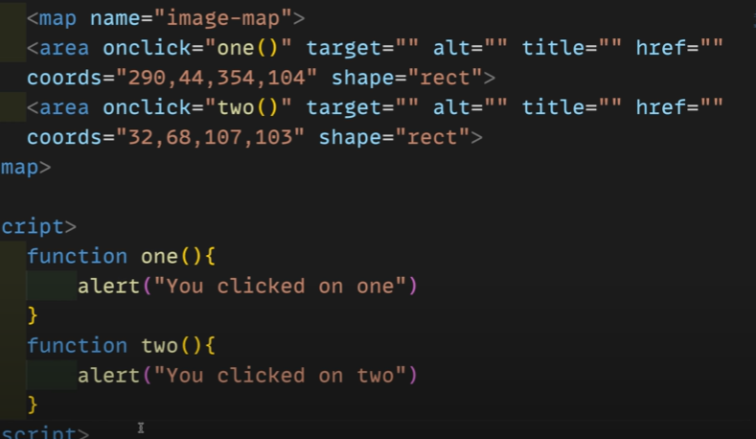

Tables in HTML in HINDI

100% width mhnje srv screen vr apply honar

Border collapse //double border gayab honar

Text aalign

Row purn asto, ek unit mhnje cell

Th mdhe col span mhnje kiti jaga occupi krel, ex lunch break cha column mtha rahto

Same rowspan asto

<th rowspan="3 " colspan="3">Country name</th>

Assign

Tfoot

List

Unordered list dot asto

Ul>li*5{1}

Ordered list number asto

Type attr ctrl space ne type bghu shkto

Nesting list

Datalist>datatable>data description

Block level element – screen chi purn space ghete , inspect krun bghu shkto ex para

Inline element – thodi space ghete ex. Span

# Class ID and iframe

# Classes and ID are mainly used for selecting elements

# Recently frameworks uniqueclass and ID generate krtat

# Iframe page within page add krtoEkhadya food delivery website vr map add krne

# Security issue mule ki use krtat

# Malicious site or content iframe cha use kru n add kele tr

# Ifram use kraychya adhi ispection is needed

# Head Tag in HTML

<meta name="viewport" content="width=device-width, initial-scale=1.0">

Widht hi device chi width rahar initial scale (mhnje zoom) he 1.0 zoom rahnar , iitiam scale range 0.1 to 10

Specially made for mob dev , mhnun web page vr kam nhi krnar

Head is used for

<title>Document</title>

    <style></style>

    <meta charset="UTF-8">

# HTML semantics

Code tag- kontahi code lihu shkto

Kbd = keyboard

Samp tag

Var tag

Pre tag

Semantics added recently

Header

Nav

Section

Article

Aside

Footer

Summary

Details

He ata tag mhnun use kru shkto adhi ya tagche je naw ahe tyala class che naw dyayche div mdhe ex <div class=”header”> </div>

pn ata tya nawache tag bnwle donhi pn way use kru shkto

yalach html modern **semnatics** (mdn search) mhntat

# HTML forms and forms attributes

User jwlun data server vr send krnyasathi forms use hotat (buttons pn use hotat)

Forms mdhl attri acftion mhnje data kothe senf kraycha ahe ex url

Methos get ani post , get encryptes nhi ahe(link mdhe show hoto) , post encrypted ahe

Label asel tr changl rahte input sobt

Label mdhl for ani input mdhl id same asel tr te ekmekana related ahe as show hot ani label vr click kel ki te input ve jate

If method **get** server jwl info jate

Post mdhe info clear txt mdhe nhi janat pn action mdhe define kraw lagel ki info kothe janar ahe

Attr of form

Action

Method

Accept-charset=’utf-8’

Autocomplte =’on/of’ (auto sugg hwe ki nhi bank details/senisitive of )

Enctype= browser through image add kru skto kiwa nhi

Novalidtae = withput validation submit honar info server vr

# Types of input forms

 <input  value="reset" type="reset">

As kel ki fkt default value cleanr nhi honar but new clear /reset honar ani type reset kel tr input tag he button sarkh behave krel

Select option

Datalist

Mdn form input